County AGM – Friday 19th November 2021

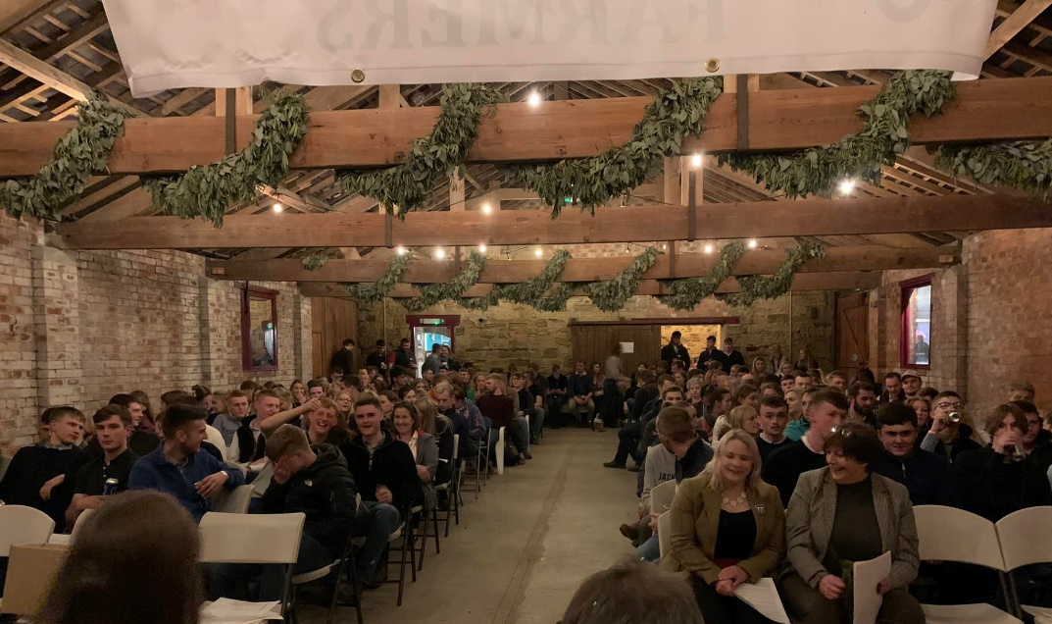

WHAT A NIGHT!!!
After a year of negotiating our way through many changes in Covid restrictions it was so good to finally be able to meet in person and all under the same roof! The beautiful surroundings of Lough House Farm set the scene for a night to celebrate the achievements of the year and elect new county officials.

Many congratulations to those who won the MANY trophies
Results are as follows:
Chalmers Shield for Senior Competitions - Bellingham YFC
Dixon Shield for Junior Competitions - Whitley Chapel YFC
National Sheep Shearing Award - Ciaran McNulty (Alnwick YFC)
Finalist of National Member of the Year - Vicky Harrison (Stamfordham YFC)
Cambo Cup (Best Club in Stockjudging) - Bellingham YFC
Morag Rose Bowl (Best Competitor in Flower Arranging) - Gina Tailford (Shaftoe YFC)
Steven Wake Trophy (Best Male Competitor in Flower Arranging) - Lewis Browell (Bellingham YFC)
Ponteland Cup (Best Competitor in the Fashion Competition) - Lillie from Haltwhistle YFC
Hollie Brown Memorial Cup (Best Club in the Boat Race) - Bellingham YFC
Northumberland National Park Trophy (Best Traditional Skill) - Will from Whitley Chapel YFC
Junior Achievement Rose Bowl - Jess from Cambo YFC
Industrial Cup (Best Club in the Industrial Section) - Bellingham YFC
The Laidler Family Shield for Best Club Display - Cambo YFC
Wooler Trophy (Best smallest 50% of competing Clubs) - Stamfordham YFC
Stamfordham Cup (Rally Runners Up) - Cambo YFC
Rally Shield - Bellingham YFC
Dennis Common Cup (Mens Tug of War) - Haltwhistle YFC
Hexham Courant Trophy (Ladies Tug of War) - Haltwhistle YFC
Junior Mixed Tug of War Team - Cambo YFC
Quoits Winners - Shaftoe YFC
Kershaw Cup (Highest Percentage Increase in Members) - Tritlington YFC
County Rose Bowl (Best Secretary’s Books) - Lauren Clark (Coquetdale YFC )
R.B.Oates Cup (Best Treasurer’s Books) - Amy from Haltwhistle YFC
Di Harrison Award (Best Club Programme) - Alnwick YFC
Dawson Trophy (Charitable Work) - Alnwick YFC
McLaren Griffin Bowl (Most Improved Club) - Tritlington YFC
Farmwrite Award (Best Written Article) - Will from Stamfordham YFC
Oliver Award (Outstanding Member Award) - Lauren from Whitley Chapel YFC
County Staff Special Achievement Award - Lillie & Amy from Haltwhistle YFC
Member of the Year (Under 18) - Isabel from Bellingham YFC
Member of the Year (Over 18) - Leanne Little (Bellingham YFC)
Club of the Year - Alnwick YFC

County Officials 2021/22
County Chair – Rebecca Maitland
Vice County Chair – David Robson
Junior County Chair – Ellie Burn
County President – Alan Jackson
Vice President – Angus Graham
Junior Vice President – Liz Grix

