Northumberland YFC – County AGM
18th November 2022
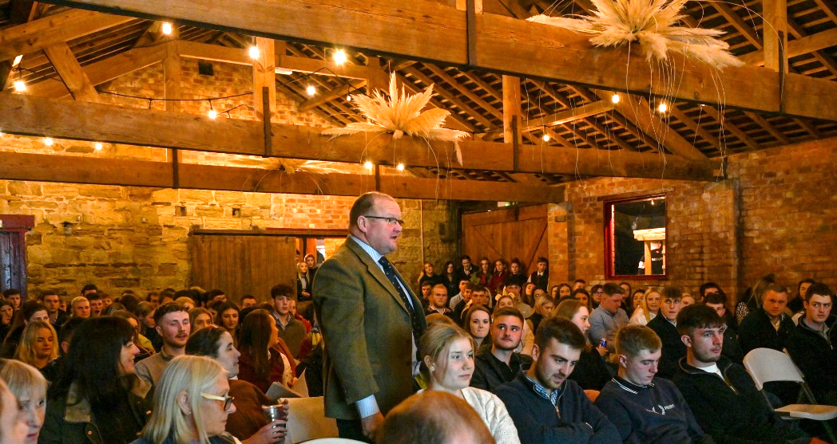

The 90th Annual General Meeting of the Northumberland Federation of Young Farmers Clubs took place on Friday 18th November 2022. Held at Lough House Farm, Stannington by kind permission of the Dungait family the room was full to the rafters with over 140 members and guests in attendance.
Retiring President Alan Jackson and County Chair Rebecca Maitland outlined the many fantastic achievements in what has been a busy year with all competitions and county events now back to running as normal.
Trophies and Awards were presented as follows:
Chalmers Shield (Senior Competitions) – Bellingham YFC
Dixon Shield (Junior Competitions) – Bellingham YFC
Junior Public Speaking – Bellingham YFC
Intermediate Speaking (Call my Bluff) – Bellingham YFC
Senior Speaking (Brainstrust) – Cambo YFC
Kershaw Cup (Highest Percentage Increase in Membership) – Whitley Chapel YFC
County Rose Bowl (Best Secretary Books) – Megan Campbell (Tritlington YFC)
R B Oates Cup (Best Treasurers Books) – Kate Grix (Cambo YFC)
Di Harrison Award (Best Club Programme) – Tritlington YFC
Dawson Trophy (Charity/Community Work) – Cambo YFC
McLaren Griffen Bowl (Most Improved Club) – Coquetdale YFC
Farmwrite Award (Best Written Article) – Andy Harvey (Whitley Chapel YFC)
Oliver Award (Members not Previously Recognised/Outstanding Service) – James Little (Shaftoe YFC)
County Staff Special Achievement Award – Hannah Robinson (Cambo YFC)
Member of the Year (Under 18) – Molly (Stamfordham YFC)
Member of the Year (Over 18) – Ellie Burn (Tritlington YFC)
Club of the Year – Awarded Jointly to Cambo YFC and Tritlington YFC
Well done to all our winners!

The newly elected County Officers are:
President: Mr Angus Graham
Chairman: Mr David Robson
Vice President: Mrs Liz Grix
Vice Chair: Miss Ellie Burn
Junior Vice President: Stuart Carr
Junior Vice Chairman: Sam Richardson

