Northumberland YFC – County AGM
17th November 2023

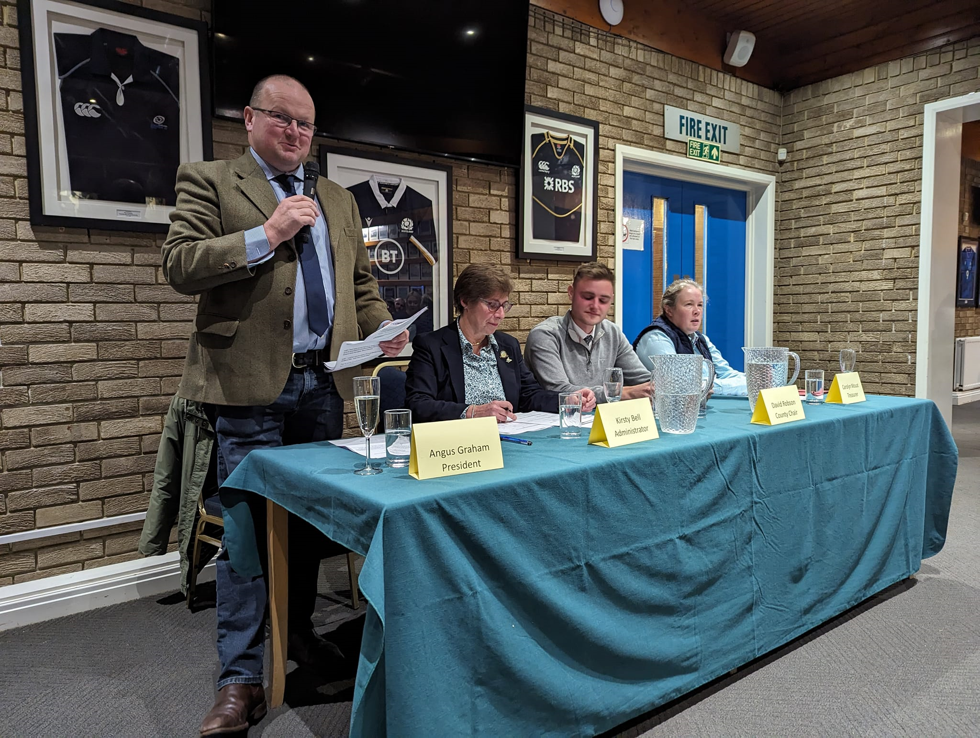
The 91st Annual General Meeting of the Northumberland Federation of Young Farmers Clubs took place on Friday 17th November 2023. Held at Tynedale Rugby Club, Corbridge the room was full with over 80 members and guests in attendance.
Retiring President Angus Graham and County Chair David Robson outlined the many fantastic achievements in what has been a busy year which ended with the 90th Anniversary Ball held at St James’ Park, Newcastle the previous weekend where nearly 800 past and present members danced the night away.
Trophies and Awards were presented as follows:
Chalmers Shield (Senior Competitions) – Cambo YFC
Dixon Shield (Junior Competitions) – Bellingham YFC
Kershaw Cup (Highest Percentage Increase in Membership) – Bellingham YFC
County Rose Bowl (Best Secretary Books) – Leanne Little (Bellingham YFC)
R B Oates Cup (Best Treasurers Books) – Jessica Robinson (Cambo YFC)
Di Harrison Award (Best Club Programme) – Leanne Little (Bellingham YFC)
Dawson Trophy (Charity/Community Work) – Stamfordham YFC
McLaren Griffen Bowl (Most Improved Club) – Haltwhistle YFC
Farmwrite Award (Best Club scrapbook) – Jodie Wigham (Haltwhistle YFC)
Oliver Award (Members not Previously Recognised/Outstanding Service) – Joseph Thompson (Cambo YFC)
County Staff Special Achievement Award – Bethany Marshall (Whitley Chapel YFC)
Member of the Year (Under 18) – Connie (Whitley Chapel YFC)
Fenwick Jackson Legacy Award, Member of the Year (Over 18) – Stuart MacDonald (Shaftoe YFC)
Club of the Year – Whitley Chapel YFC
Well done to all our winners!

The newly elected County Officers are:
President: Mrs Liz Grix
Chairman: Miss Ellie Burn
Vice President: Mr Stuart Carr
Vice Chair: Mr Sam Richardson
Junior Vice President: Mr Philip Walton
Junior Vice Chairman: Miss Bethany Marshall

